AT89C2051 Reference

Program Memory: Data Memory:
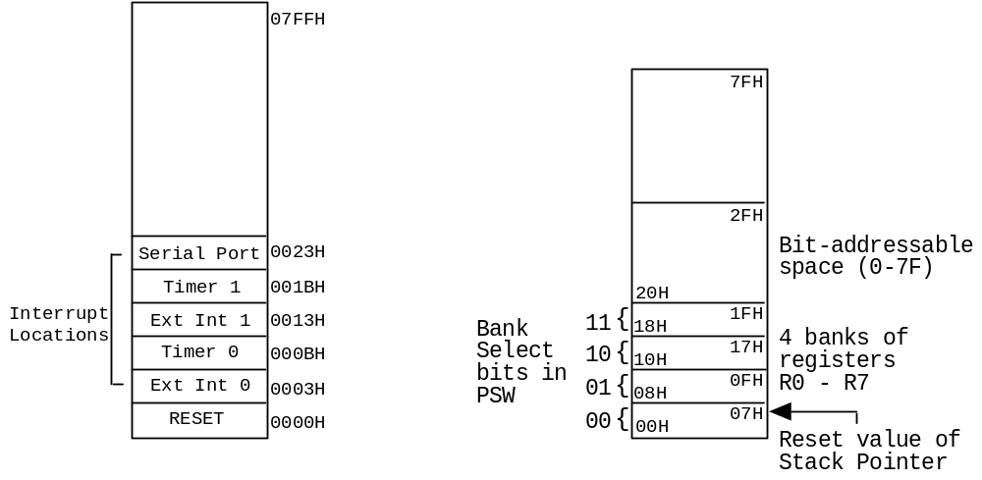
Program Counter: 16 bit register restricted to 0000H -> 07FFH

Special Function Registers (SFR) Space:
Byte Address | Name | Description | Bits
81H | SP | Stack Pointer | not bit addressable
82H | DPL | Low byte of DPTR | not bit addressable
83H | DPH | High byte of DPTR | not bit addressable
87H | PCON | Power control | not bit addressable
88H | TCON | Timer control | TF1-TR1-TF0-TR0-IE1-IT1-IE0-IT0
89H | TMOD | Timer mode control | not bit addressable
8AH | TL0 | Timer 0 low byte | not bit addressable
8BH | TL1 | Timer 1 low byte | not bit addressable
8CH | TH0 | Timer 0 high byte | not bit addressable
8DH | TH1 | Timer 1 high byte | not bit addressable
90H | P1 | Parallel port 1 | P1.7 -> P1.0
98H | SCON | Serial control | SM0-SM1-SM2-REN-TB8-RB8-TI -RI
99H | SBUF | Serial buffer | not bit addressable
A8H | IE | Interrupt Enable | EA - - -ES -ET1-EX1-ET0-EX0
B0H | P3 | Parallel port 3 | P3.7 -> P3.0
B8H | IP | Interrupt priority | - - -PS -PT1-PX1-PT0-PX0
D0H | PSW | Program Status Word | CY -AC -F0 -RS1-RS0-OV -F1 -P
E0H | ACC | Accumulator | ACC.7 -> ACC.0
F0H | B | B register | B.7 -> B.0

Interrupt control register
IE: EA Global bit to enable interrupts
ES,ETx Serial interrupt (either RI or TI), Clock interrupt on overflow

Power control register. PCON: set to 2 will stop the processor

Timer control and mode registers - 2 timers, 0 and 1
TCON: TF0/TF1 Timer overflow flag timers 0/1
TR0/TR1 Timer run control bit. Set by software to switch timer ON
TMOD: mode1-mode0 2 4-bit nibbles. Timer 1 high order nibble, Timer 0 low order.
mode = 0 13 bit timer
mode = 1 16 bit timer
mode = 2 8 bit auto-reload timer. THx -> TLx on overflow. Used by Serial
i/o as bit rate (*32). 0FDH in THx gives 9600bps for 11.059Mhz clock

Serial control register
SCON: SM0-SM1-SM2-REN-TB8-RB8 should be set to 010100 for normal operation
TI set when the character has been transmitted
RI set when a character is received

Addressing Modes:
Rn = Register R0 - R7 of the currently selected register bank.
direct = 8-bit internal data location's address. This could be an internal Data
RAM location (0-127) or a SFR.
@Ri = 8-bit internal Data RAM location addressed indirectly through R0 or R1.
#data = 8-bit constant included in instruction.
#data16 = 16-bit constant included in instruction.
addr11 = 11-bit destination address. Used by ACALL and AJMP.
The branch will be within the same 2K byte page of Program Memory as
the first byte of the following instruction.
addr16 = 16-bit destination address. Used by LCALL and LJMP.
A branch can be anywhere within the 2K byte Program Memory address
space.
rel = Signed (two's complement) 8-bit offset byte. Used by SJMP and all
conditional jumps. Range is -128 to +127 bytes relative to first
byte of the following instruction.
bit = Direct addressed bit in internal Data RAM or SFR.

Arithmetic | Byte | Cycle | C OV AC
ADD A,Rn | Add register to Accumulator | 1 | 1 | X X X
ADD A,direct | Add direct byte to Accumulator | 2 | 1 | X X X
ADD A,@Ri | Add indirect RAM to Accumulator | 1 | 1 | X X X
ADD A,#data | Add immediate data to Accumulator | 2 | 1 | X X X
ADDC A,Rn | Add register to Acc. with Carry | 1 | 1 | X X X
ADDC A,direct | Add direct byte to Acc. with Carry | 2 | 1 | X X X
ADDC A,@Ri | Add indirect RAM to Acc. with Carry | 1 | 1 | X X X
ADDC A,#data | Add immediate data to Acc. / Carry | 2 | 1 | X X X
SUBB A,Rn | Subtract reg. from Acc. with borrow | 1 | 1 | X X X
SUBB A,direct | Sub. direct byte from Acc. / borrow | 2 | 1 | X X X
SUBB A,@Ri | Sub. indirect RAM from Acc./ borrow | 1 | 1 | X X X
SUBB A,#data | Sub. imm. data from Acc. / borrow | 2 | 1 | X X X
INC A | Increment Accumulator | 1 | 1 |
INC Rn | Increment register | 1 | 1 |
INC direct | Increment direct byte | 2 | 1 |
INC @Ri | Increment indirect RAM | 1 | 1 |
DEC A | Decrement Accumulator | 1 | 1 |
DEC Rn | Decrement register | 1 | 1 |
DEC direct | Decrement direct byte | 2 | 1 |
DEC @Ri | Decrement indirect RAM | 1 | 1 |
INC DPTR | Increment Data Pointer | 1 | 2 |
MUL AB | Multiply A and B | 1 | 4 | 0 X
DIV AB | Divide A by B | 1 | 4 | 0 X
DA A | Decimal adjust Accumulator | 1 | 1 | X

Logical | Byte | Cycle | C OV AC
ANL A,Rn | AND register to Accumulator | 1 | 1 |
ANL A,direct | AND direct byte to Accumulator | 2 | 1 |
ANL A,@Ri | AND indirect RAM to Accumulator | 1 | 1 |
ANL A,#data | AND immediate data to Accumulator | 2 | 1 |
ANL direct,A | AND Accumulator to direct byte | 2 | 1 |
ANL direct,#data | AND immediate data to direct byte | 3 | 2 |
ORL A,Rn | OR register to Accumulator | 1 | 1 |
ORL A,direct | OR direct byte to Accumulator | 2 | 1 |
ORL A,@Ri | OR indirect RAM to Accumulator | 1 | 1 |
ORL A,#data | OR immediate data to Accumulator | 2 | 1 |
ORL direct,A | OR Accumulator to direct byte | 2 | 1 |
ORL direct,#data | OR immediate data to direct byte | 3 | 2 |
XRL A,Rn | Exc-OR register to Accumulator | 1 | 1 |
XRL A,direct | Exc-OR direct byte to Accumulator | 2 | 1 |
XRL A,@Ri | Exc-OR indirect RAM to Accumulator | 1 | 1 |
XRL A,#data | Exc-OR immediate data to Acc. | 2 | 1 |
XRL direct,A | Exc-OR Accumulator to direct byte | 2 | 1 |
XRL direct,#data | Exc-OR imm. data to direct byte | 3 | 2 |
CLR A | Clear Accumulator | 1 | 1 |
CPL A | Complement Accumulator | 1 | 1 |
RL A | Rotate Accumulator left | 1 | 1 |
RLC A | Rotate Acc. left through Carry | 1 | 1 | X
RR A | Rotate Accumulator right | 1 | 1 |
RRC A | Rotate Acc. right through Carry | 1 | 1 | X
SWAP A | Swap nibbles within the Accumulator | 1 | 1 |
NOP | No operation | 1 | 1 |

Boolean | Byte | Cycle | C OV AC
CLR C | Clear Carry | 1 | 1 | 0
CLR bit | Clear direct bit | 2 | 1 |
SETB C | Set Carry | 1 | 1 | 1
SETB bit | Set direct bit | 2 | 1 |
CPL C | Complement Carry | 1 | 1 | X
CPL bit | Complement direct bit | 2 | 1 |
ANL C,bit | AND direct bit to Carry | 2 | 2 | X
ANL C,/bit | AND complement of dir. bit to Carry | 2 | 2 | X
ORL C,bit | OR direct bit to Carry | 2 | 2 | X
ORL C,/bit | OR complement of dir. bit to Carry | 2 | 2 | X
MOV C,bit | Move direct bit to Carry | 2 | 1 | X
MOV bit,C | Move Carry to direct bit | 2 | 2 |
JC rel | Jump if Carry is set | 2 | 2 |
JNC rel | Jump if Carry not set | 2 | 2 |
JB bit,rel | Jump if direct bit is set | 3 | 2 |
JNB bit,rel | Jump if direct bit is not set | 3 | 2 |
JBC bit,rel | Jump if dir. bit is set & clear bit | 3 | 2 |

Data transfer | Byte | Cycle | C OV AC
MOV A,Rn | Move register to Accumulator | 1 | 1 |
MOV A,direct | Move direct byte to Accumulator | 2 | 1 |
MOV A,@Ri | Move indirect RAM to Accumulator | 1 | 1 |
MOV A,#data | Move immediate data to Accumulator | 2 | 1 |
MOV Rn,A | Move Accumulator to register | 1 | 1 |
MOV Rn,direct | Move direct byte to register | 2 | 2 |
MOV Rn,#data | Move immediate data to register | 2 | 1 |
MOV direct,A | Move Accumulator to direct byte | 2 | 1 |
MOV direct,Rn | Move register to direct byte | 2 | 2 |
MOV direct,direct| Move direct byte to direct byte | 3 | 2 |
MOV direct,@Ri | Move indirect RAM to direct byte | 2 | 2 |
MOV direct,#data | Move immediate data to direct byte | 3 | 2 |
MOV @Ri,A | Move Accumulator to indirect RAM | 1 | 1 |
MOV @Ri,direct | Move direct byte to indirect RAM | 2 | 2 |
MOV @Ri,#data | Move immediate data to indirect RAM | 2 | 1 |
MOV DPTR,#data16 | Load Data Pointer with 16-bit const | 3 | 2 |
MOVC A,@A+DPTR | Move Code byte rel. to DPTR to Acc. | 1 | 2 |
MOVC A,@A+PC | Move Code byte rel. to PC to Acc. | 1 | 2 |
PUSH direct | Push direct byte onto stack | 2 | 2 |
POP direct | Pop direct byte from stack | 2 | 2 |
XCH A,Rn | Exchange register with Accumulator | 1 | 1 |
XCH A,direct | Exchange direct byte with Acc. | 2 | 1 |
XCH A,@Ri | Exchange indirect RAM with Acc. | 1 | 1 |
XCHD A,@Ri | Exchange low order digit indirect | | |
| RAM with Accumulator | 1 | 1 |

Branching | Byte | Cycle | C OV AC
ACALL addr11 | Absolute subroutine call | 2 | 2 |
LCALL addr16 | Long subroutine call | 3 | 2 |
RET | Return from subroutine | 1 | 2 |
RETI | Return from interrupt | 1 | 2 |
AJMP addr11 | Absolute jump | 2 | 2 |
LJMP addr16 | Long jump | 3 | 2 |
SJMP rel | Short jump (relative address) | 2 | 2 |
JMP @A+DPTR | Jump indirect relative to the DPTR | 1 | 2 |
JZ rel | Jump if Accumulator is zero | 2 | 2 |
JNZ rel | Jump if Accumulator is not zero | 2 | 2 |
CJNE A,direct,rel | Compare direct byte to Accumulator | | |
| and jump if not equal | 3 | 2 | X
CJNE A,#data,rel | Compare immediate data to | | |
| Accumulator and jump if not equal | 3 | 2 | X
CJNE Rn,#data,rel | Compare immediate data to register | | |
| and jump if not equal | 3 | 2 | X
CJNE @Ri,#data,rel| Compare immediate data to indirect | | |
| RAM and jump if not equal | 3 | 2 | X
DJNZ Rn,rel | Decr. register and jump if not zero | 2 | 2 |
DJNZ direct,rel | Decrement <byte>, jump if not zero | 3 | 2 |

Constants:
Numbers: Decimal - 34, Binary - 01110101B, Hexadecimal - 0A8H
Characters: ‘A’ - ‘Abc’ - ‘A’,00DH,00AH (mixed mode)
Operators: ()’s + - / * MOD SHR SHL NOT AND OR XOR

Assembler directives and controls
$MOD2051 Include file MOD2051 - defines 2051 symbols
; Everything following a semicolon is a comment
Label: Labels of statements used for program branches.
TEN EQU 10 EQUates 10 with the symbol TEN
ON_FLAG BIT 6 Assigns bit 6 (either data or SFR space) to the symbol ON_FLAG
BUFFER DATA 32 Assigns byte 32 (either data or SFR space) to the symbol BUFFER
RESET CODE 0 Assigns 0 in code space to the symbol RESET
DSEG Makes the data space the currently selected segment
CSEG Makes the code space the currently selected segment
BSEG Makes the bit addressable area of data space the cur sel seg.
SP_BUFFER: DS 6 Reserves 6 bytes of storage in data space. DSEG must be active.
IO_MAP: DBIT 8 Reserves 8 bits of storage in bit space. BSEG must be active.
MESS1: DB ‘Hi’ Store byte constants in code space.
ORG 56H Specify a value for the cur sel segments location counter.

